EXP NO 7

Experiment with different layouts and color schemes for an app. Collect user feedback on aesthetics and usability using GIMP(GNU Image Manipulation Program (GIMP)

App Layout & Color Scheme

AIM :

The aim is to trial different app layouts and color schemes and evaluate user feedback on aesthetics and usability using GIMP.

Base Layout:


Added UI Elements:

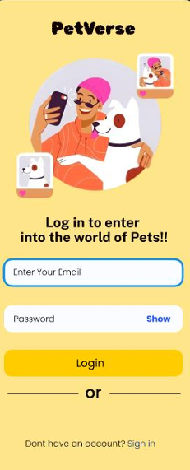

Organised Layers:

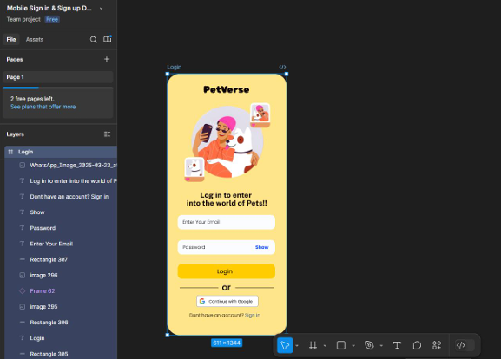

Experiment with Color Schemes:

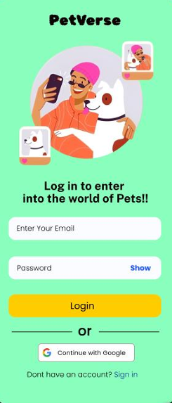

Collected User Feedback
Google Form Feedback Analysis: Yellow vs Green Variant
1. Which layout do you prefer?
Yellow Variant: 60%
Green Variant: 40%
Interpretation: Most users preferred the Yellow layout,
indicating it may be more visually appealing or better structured.
2. Which color scheme feels most professional?
Yellow Variant: 65%
Green Variant: 35%
Interpretation: The Yellow color scheme is seen as more
professional, potentially due to its brightness or better contrast.
3. How easy was it to find buttons and inputs?
Yellow Variant: 90%
Green Variant: 10%
Interpretation: Navigation and usability are clearly better in
the Yellow variant, with a very high ease-of-use score.
4. Which layout would you recommend to others?
Yellow Variant: 55%
Green Variant: 45%
Interpretation: While Yellow still leads, this is the closest
category, suggesting Green also has its merits worth exploring.

Visual Representation

As shown in the graph above, Yellow dominates across all
feedback categories, especially in usability and professional
appearance. Green, while liked by some, consistently ranks lower.
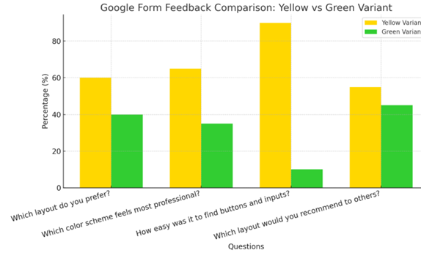

One suggestion:
It would be even better and more convenient if there were
additional login options like Google and Apple ID login buttons it
would make signing in faster and easier for users.

➔ Iterate and Refine:
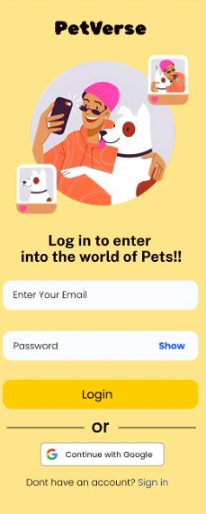

A user-informed, visually polished mobile app layout was created using GIMP with variations in design and color scheme. Feedback-driven improvements enhanced both aesthetic appeal and usability.

